This can be you
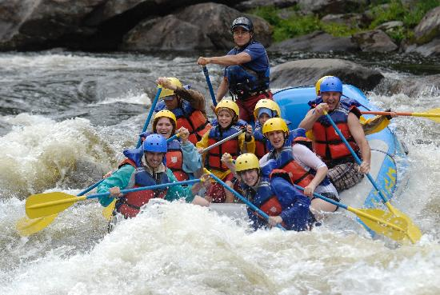
White Water Rafting, 8/31, $64 due 8/4
1. Sang | 7. | 13.
2. David S. | 8. | 14.
3. | 9. | 15.
4. | 10. | 16.
5. | 11. | 17.
6. | 12. | 18.

